Stockeld Park launches its biggest & brightest Christmas yet with the return of the Gold Christmas Tickets!
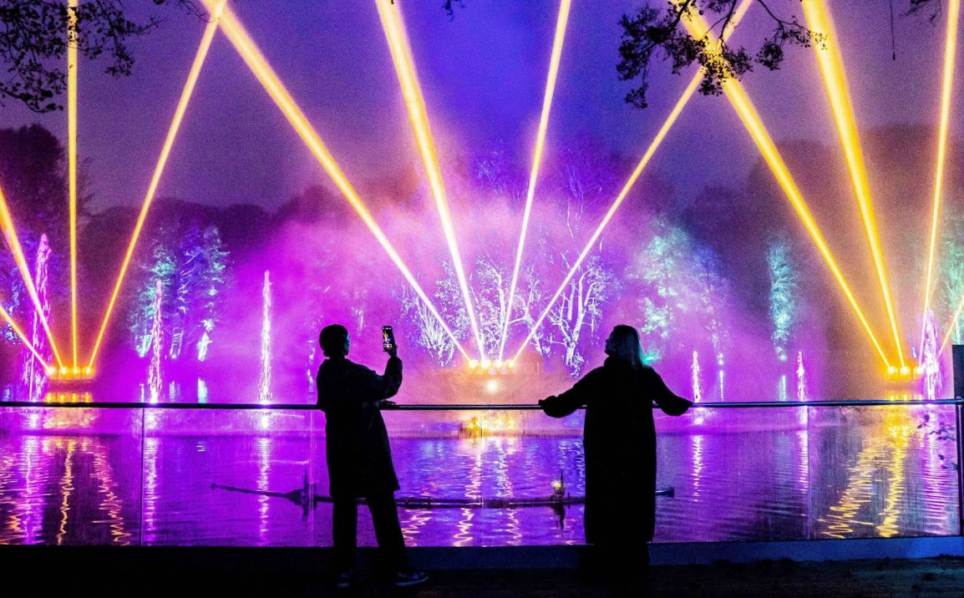

Stockeld Park launches Gold Tickets for the biggest and best Christmas experience yet.
Stockeld Park, Yorkshire’s much-loved family adventure destination, is getting into the Christmas spirit early this year. Following the huge success of last year’s festive season, the park is set to return with its most magical Christmas experience yet, and it all starts with the launch of their highly anticipated Gold Christmas Tickets.
Gold Tickets go on general sale this Saturday, 28th June, but those signed up to the Stockeld Park mailing list by midnight on Thursday will receive exclusive pre-sale access from Friday, 27th June.
These premium tickets offer full access to Stockeld’s Christmas spectacular, including the ever-popular interactive Santa’s Grotto, the UK’s original first-ever walk-through Winter Illuminations, and a brand new festive stage show in the exclusive Stockeld Theatre.
Stockeld Park is investing £180,000 into new displays and equipment, building on the £150,000 invested last year. The team’s aim is simple: to deliver a Christmas experience unlike anything else in the UK.
This year’s show brings a fresh sprinkling of festive fun as families are invited to join the mischief with brand-new park characters Cookie the Elf, Crumble the Elf, and Jack Frost himself in a performance of How Jack Frost Stole Christmas. Packed with laughs and Christmas cheer, the show promises to be a highlight for visitors of all ages.
The Grotto also sees exciting updates in 2025, including the introduction of Santa’s Sorting Office, where families will begin their journey by witnessing letters arriving from all around the world. Along the way, children will encounter new interactive moments, including one of Santa’s elves hard at work trying to build toys.
Stockeld’s famous Winter Illuminations are also back, and this year, they’re bigger, brighter, and more magical than ever. Featuring brand-new installations, the illuminated trail winds through the park’s enchanted forest, transforming it into a glowing wonderland of twinkling lights and festive displays. And of course, Santa will be welcoming families into his magical grotto for a memorable meeting, complete with a special gift for every child.
With all these festive favourites returning, and new surprises in store, the 2025 season is set to be the most exciting yet at Stockeld Park.
The Gold Christmas Tickets go on sale Friday 27th June and are expected to sell out quickly. Secure yours now via https://stockeldpark.co.uk/plan-your-day/tickets-prices/christmas-ticket-options/
Ends
For further information please contact the Stockeld Park press office team on stockeld@prohibitionpr.co.uk
Notes to editor
About Stockeld Park
Open throughout the year, Stockeld Park is a unique all-weather family attraction located near Wetherby in Yorkshire.
The renowned Enchanted Forest is filled with magical interactive fun and is home to five themed adventure playgrounds.
The adventure doesn’t end there, the giant yew tree maze has over a mile of paths with surprises hidden throughout, and the indoor Playhive is one of Europe’s largest indoor play centres. Adventure across high-level walkways and down spiralling tunnel slides as you journey through four interconnected worlds of space, air, jungle, and ocean.
Each season sees a different event held in the park including illuminations and Santa’s grotto in the winter, summer festival, and Halloween fun to entertain families throughout the seasons.

