Stockeld Storyworld Education - Designing a Fairy Forest House
Due to the creative nature of the project, variations are expected, but the following should act as a guide. We want children to explore imaginatively and originally, however because the completed village will be made up of a large collection of houses from different entries it is important to consider the over all effect. The village needs some uniformity of style and scale so that all the buildings work together as a whole. For this reason, please consider the following specifications and suggestions. The competition entries will be judged against the successful consideration of these. Working within the limitations of a brief is an important consideration of the build process.
Fairies are invisible to most humans and can only be seen if they choose to be, so there is no requirement to include fairy figures in the build.
Spec sheet
Size/dimensions | Main building should be no bigger than:  Height:20cm*  Length:15cm  Depth:15cm  *Features such as towers, turrets or raising the building on bases or posts can increase this but consider the overall aesthetics.
Materials | Natural:  Wood: sticks, bark, twigs, small log sections  Moss, stones, pebbles, leaves, pine cones,  Manmade:  Manmade materials can be used as long as they are designed to look natural e.g. lolly sticks for roof tiles or fencing, fake greenery or flowers, glass pebbles, modelling clay used to form objects etc. Reclaimed materials such as bottles, tin cans, containers etc. can be used to generate shapes but should be coated/decorated to look like natural materials.
Colours/decoration | Natural:  Colours should be in keeping with the natural style of the project as a whole, so things like windows, doors, fencing etc. can be highlighted in colourful paint, but painting and decoration of the house overall should blend with the natural feel of the environment and materials used.  Additional miniature decoration details can be added such as watering cans, swings, stools, tables, picture frames, clocks, ladders, wheel barrows etc.
Weather Proofing | The houses will be placed permanently outside in the forest so consideration must be given to weatherproofing.  Materials: Firstly, the design and physical construction should be sturdy and use features such as sloped roofs and curved section to allow rain to fall off. Materials should be chosen for longevity in outside conditions (e.g. hard woods not untreated MDF). You could consider a base of some kind to stop damp from the ground rotting the bottom.  Fixings: Nails and screws are good, plastic thread, wire or string could work, plastic based glues such as hot glue or silicone sealants should work but water-soluble glues such as P.V.A will not last when wet.  Coatings: You could use varnish, paint or sprayable hydrophobic protection on natural materials to prevent rotting. Plastic greenery and flowers could be used to add details. Materials such as leaves, or moss could be used if placed appropriately e.g. underneath a covered or roofed section.

Some examples of style and design
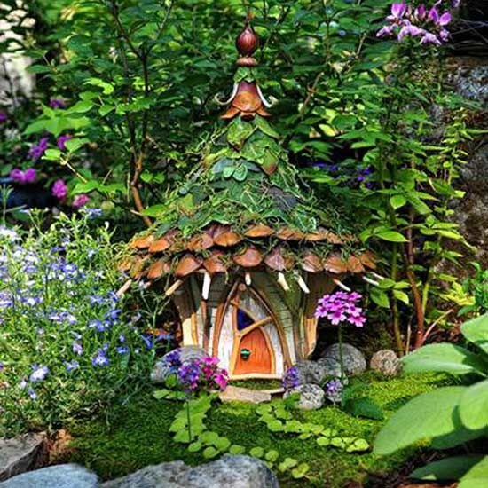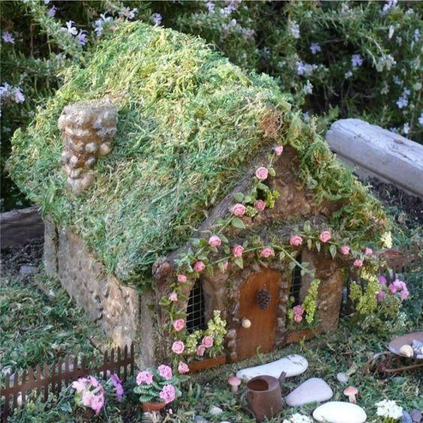
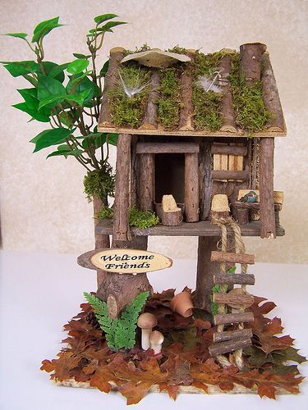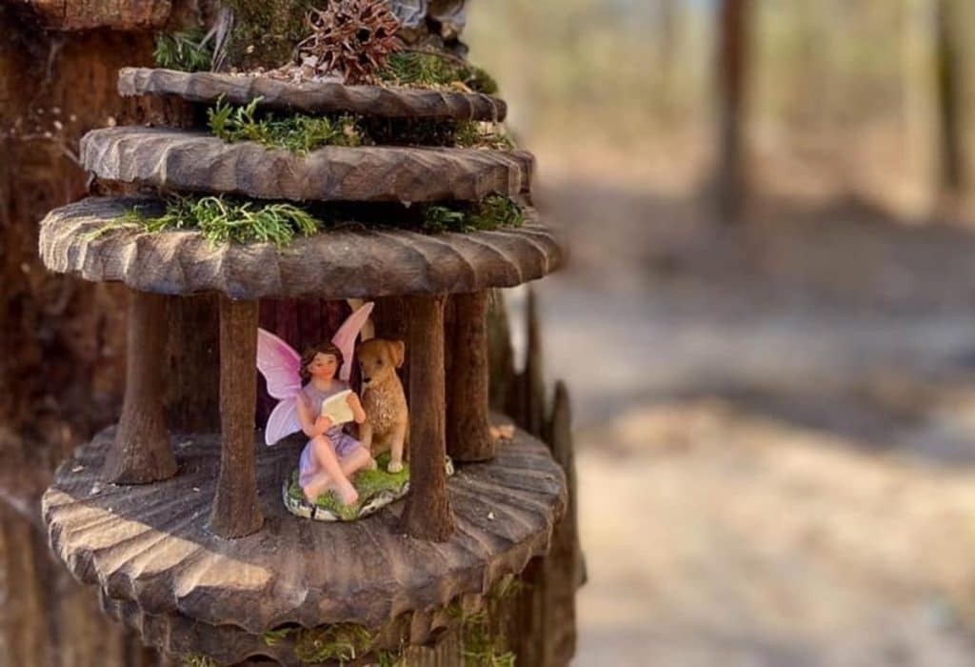
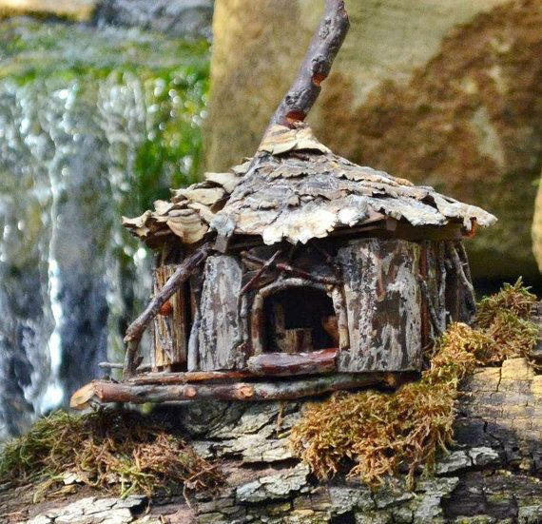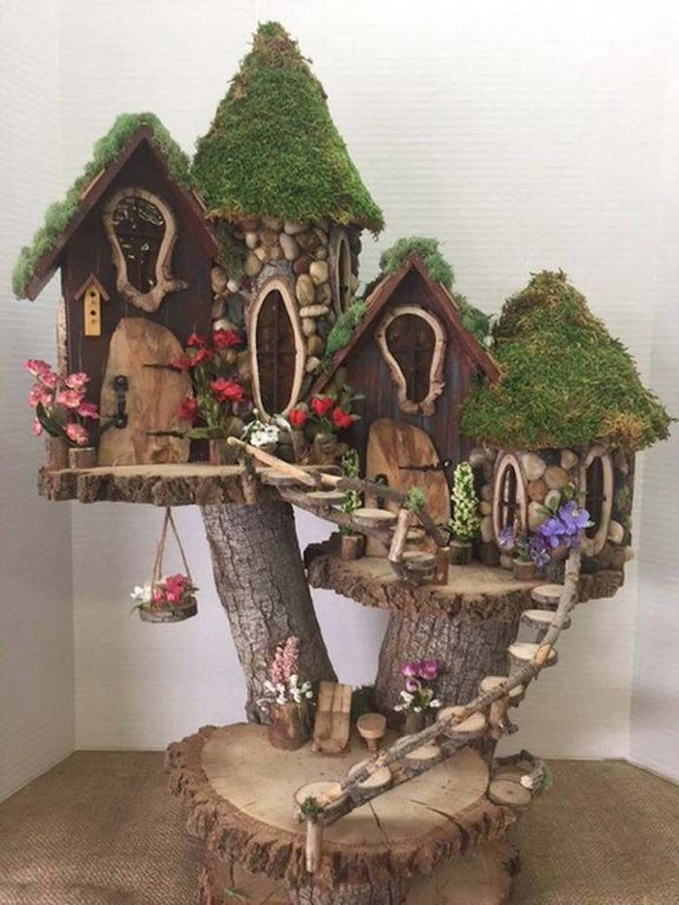
Some suggestions for activities during the build process

Curriculum Links
STEAM (whole project)
English (questioning and reasoning skills, problem solving, creative thinking)
DT (materials, design process and build, problem solving, evaluation)
Maths (data collection)
History (research and questioning skills)
Science & Geog (natural environment, properties of materials, social needs)
Art (colour matching, texture, modelling, materials, painting)

Researching Fairies and Fairy Houses - Portfolio
Spend some time looking through books and searching the internet to gather information about fairy houses.
E.g.
- What do they look like?
- What are they made of?
- What size are they?
- Where do you find them?
- What do you find inside and outside of them?
- Do they have gardens? What’s in them?
- Are they hidden or camouflaged? How?

Generate and answer some pertinent questions about Fairies.
E.g.
- What size are fairies? Do they grow over time?
- How do they move? How will this affect how they enter and move about their house?
- How long do fairies live for? How does this affect considerations for the lifespan of their house?
- What materials would a fairy have available to build a house with?
- What do fairies need from a house?
- What objects might a fairy have in their house?

Make a portfolio, including photos, sketches and written notes from all the things you’ve found.

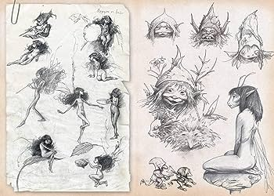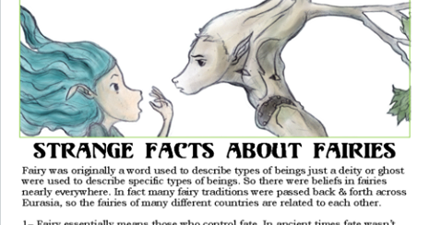
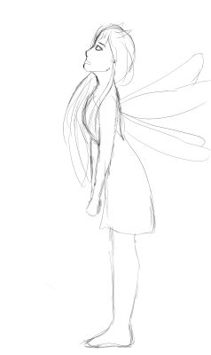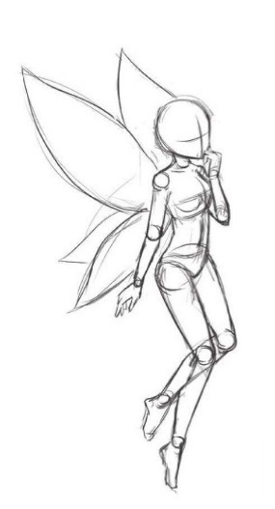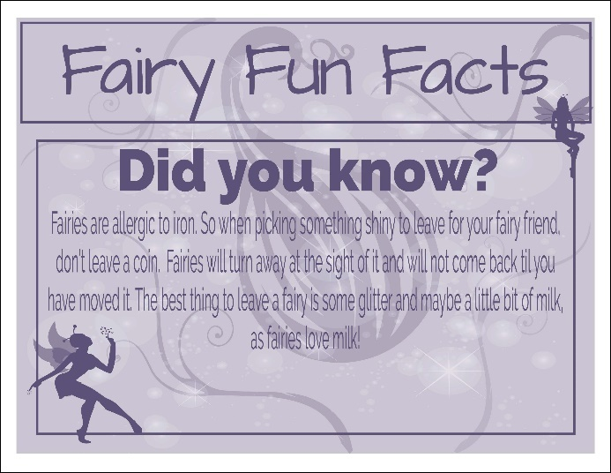

Environment Considerations – The Forest
Think about the environment in which the house will be placed.
- What is it like in a forest?
- What animals live in the forest?
- What might the weather be like over the year?
- How could the environment and the animals affect the house?
- Where would a good place be to put the house?
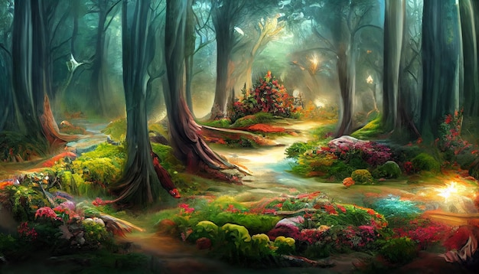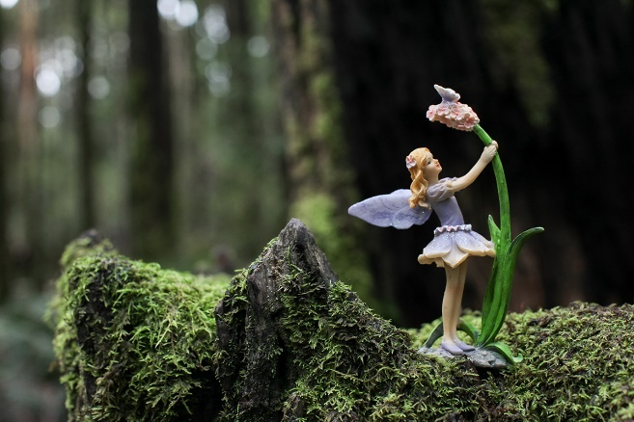

Properties of Materials Testing

The brief requires that materials are…
- Natural or natural in appearance
- Weatherproof
- Strong and hardwearing
- Can be permanently fixed with screws, nails string, wire or waterproof glues.

Design a series of tests to explore the properties of various materials to determine their suitability for the project. Use your findings to inform your design.

Material

What it was tested for.

How it was tested

Conclusion | This material is/is not suitable for building a fairy house with because…

Colour Matching and Aesthetics
Generate a colour swash for the build.
Research natural colours found in the forest. Consider how the colours will help the building blend into the environment, both aesthetically and for camouflage.
Think about the colours and textures of the materials you plan to use.

