Help Us Build a Brand New Fairy Village
Stockeld Storyworld Education Programme Competition
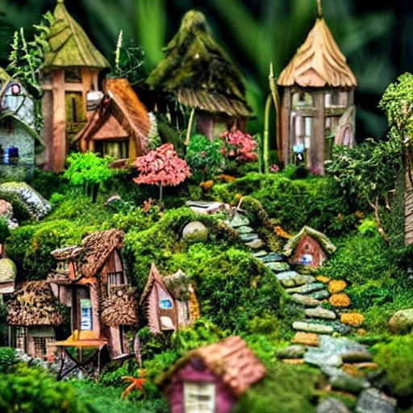

Stockeld has always encouraged interaction with our local schools. In the past this has included several competitions where children have been able to help design some of the Park’s attractions. With the introduction of our new Education Programme and School Trips, we want to bring schools onboard again through a series of incredible competitions and activities specifically for schools to engage with.
Stockeld is full of magical spaces, none more so than our fairy village of Tinkerdale. We’ve seen a huge increase in fairy folk activity in the Forest and we want to offer our fairy friends somewhere nice to stay, so we’ve decided to build a new set of houses for them, and we’d like schools to help us do it.
It’s a perfect STEAM PROJECT with a fun, creative design brief that’s sure to engage the children. From initial drawings, material selection and the build itself, you can involve children in every aspect with clear steps to help build their skills and develop their understanding of the design process.
We’ve even provided you with design process planning sheets to help them deliver the best results from their project, all free to download and use in school.
Judging entries will be a two-stage process. Initially, teachers should send their entry form and photographs of all the entries to us electronically as jpegs in zipped folders with the school’s name, class name and teacher’s name as the file name of the folder. If more than one class is taking part, send entries separately with their own entry form. We don’t need to know individuals details at this stage. We will then get back in touch with a selection of designs we like. Teachers should then use their judgement to select four final entries, based on how well those children completed the build using the design brief as success criteria. The number of winners chosen will depend on how good the entries are and how many schools take part. Winners must be able to deliver their finished houses to us, but as part of their prize they will receive a free family ticket so they can visit and deliver their house in person. Ticket delivery will be arranged through the school.
Winning entries will be used to build the Fairy Village and a plaque will be placed on the wall next to the village with all the winning entries names and schools. All schools who enter will receive a downloadable thankyou certificate for taking part. You’ll also be automatically entered into our prize draw where you could win some family tickets for fund raising and even a FREE EDUCATIONAL SCHOOL TRIP to Stockeld Park.
For full details on the design brief and to download the project sheets for your class simply visit our downloads section on our webpage...

Stockeld’s Educational Storyworld – Stockeld Park
Email: schools@stockeldpark.co.uk
Website https://stockeldpark.co.uk/stockelds-educational-storyworld/
Good luck and thank you on behalf of all the Fairies of Tinkerdale and from all of us here at Stockeld Park.
