Name:
Design Stage 1: First Draft - Imaginative
Sketch your first draft ideas for your fairy house. Don’t worry about how you will design it at this stage. Give your imagination complete freedom. Be creative.

Think about everything a fairy might need from a house. Add as many details as you can. Label each part.

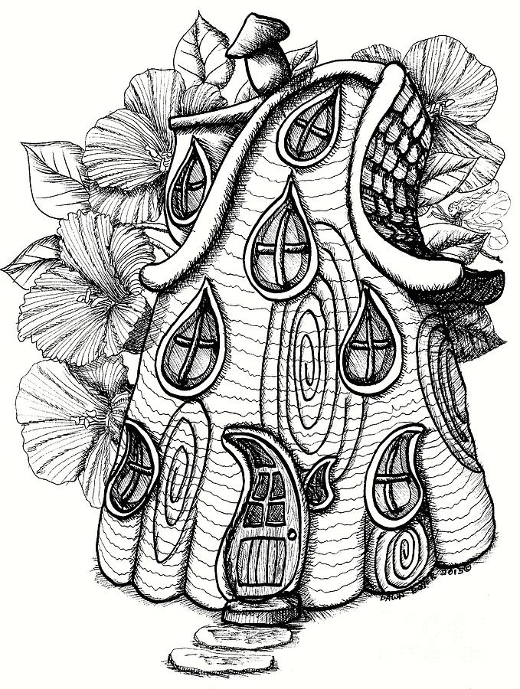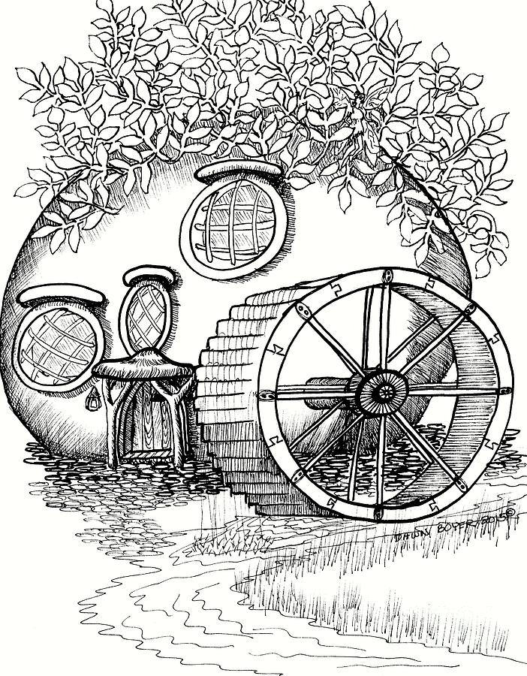
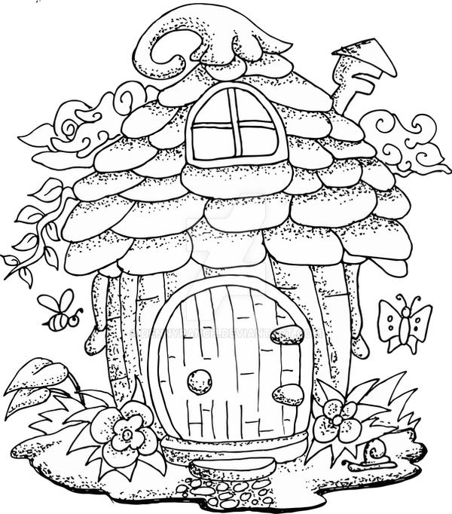
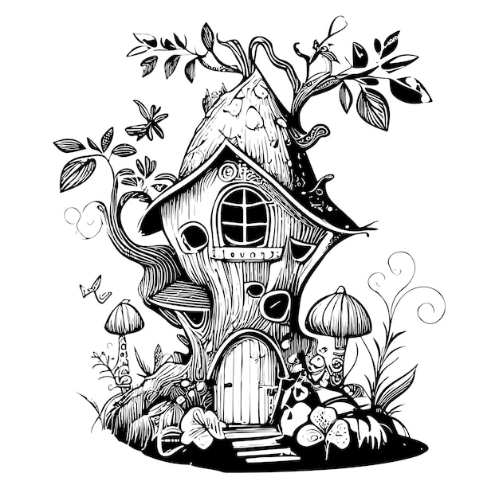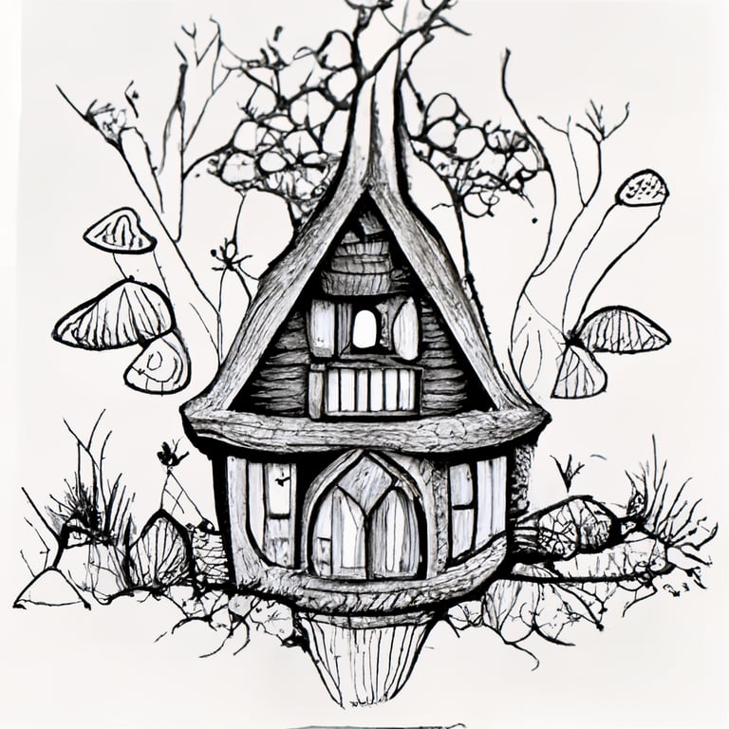

Name:
Design Stage 2: Second Draft - Practical
Consider how you are going to build your fairy house. List the materials you think you will use. Think about how you are going to attach them together. Make your drawing detailed and realistic. Label it.

Materials

Sticks/Wood planks/squares/Lolly sticks
Clay Plant pot and saucer
Stones
Moss
Outdoor paint / varnish (colour matched)

Hot glue gun
wire
string
Paint brushes

Drawing (detailed and realistic)

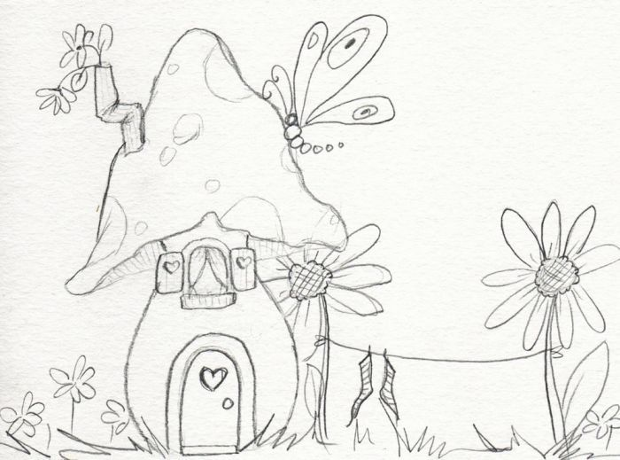

Name:
Design Stage 3: Instructions
Write out step by step instructions of how you will go about building the fairy house. Include small diagrams of each build section and instructions of what you will use and how you will put it together.

Step 1. Paint pots

Made out of Clay Pots. Clay pots are very durable and will hold up to the rainy weather. Use a saucer as a base. Paint your pots with waterproof outdoor paint.
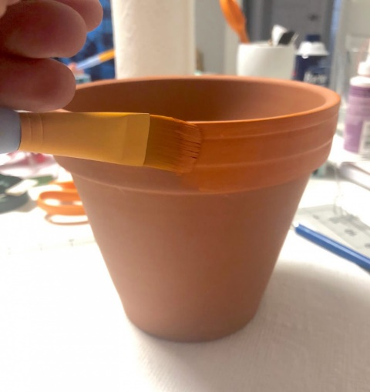
Step 2. Use pre-cut wooden door and window pieces. Paint with external paint. Attach with glue.
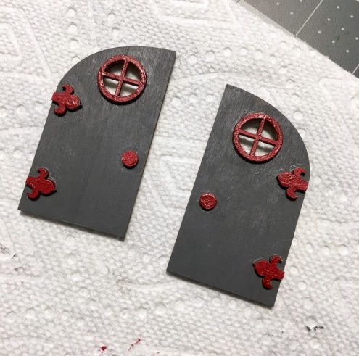
Step 3.
Add embellishments to your DIY fairy garden, like small wood circle steps. Add them with waterproof glue. Give your houses a few coats of Outdoor varnish or waterproofing spray.

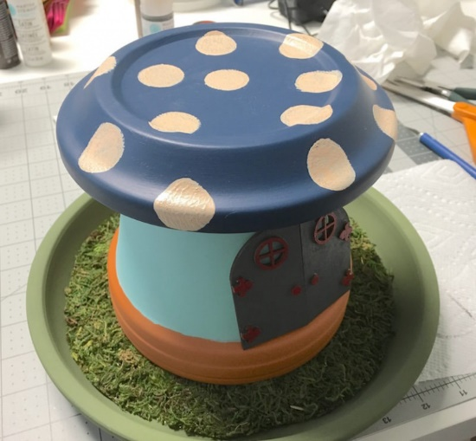

Name:
Design Stage 4: Conclusion and Learning
Photograph your finished house and stick it below or draw it exactly as it looks.

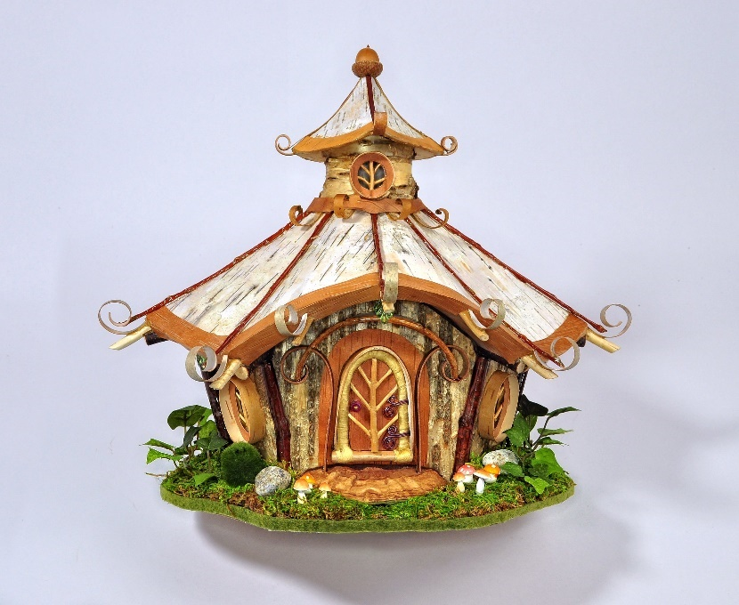

What have you learnt from the design?

What went well? What are you pleased with and why?

The pots are strong and a nice shape.
I like the colours I chose.
It was simple but effective with minimal materials.

What problems did you come up against?
How did you resolve them and what would you do differently next time?

The pots were heavy and easy to break.
It still looked a little like plant pots rather than a real miniature house.
It was hard attaching things to the pots because they were hard and you couldn’t really screw or fix things to it other than with glue.

